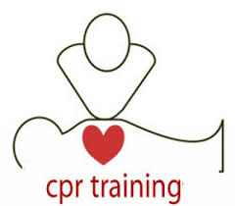
Advanced Cardiac Life Support Courses 2020
(Course aimed at Nurses, Doctors and Paramedical staff who lead and manage cardiac arrests)

Resuscitation Guidelines: Guidelines 2015/20
October 2020 | October 2020 | November 2020 | November 2020 | November 2020
29th | 31st | 6th | 7^{8h}/ 8th | 21st
HeartCode ACLS | HeartCode ACLS | HeartCode ACLS | 2 day course | HeartCode ACLS

Start time for all ACLS courses is 0745 hrs.

Courses are open to internal and external applicants.
To book a place on any of these courses please contact:
Attracta Kennedy, Resuscitation Training Officer Ext: 7466 email: a.kennedy@stmichaels.ie
Or Suzanne Clear, CNM2 Resuscitation Department Ext: 7416 email: s.clear@stmichaels.ie

Please book early as places are limited.
Remember you must have an in-date AHA BLS Certificate to attend ACLS Training.

COVID 19 Protocols remain in place for Resuscitation Training.
Do not wear Uniforms or Scrubs to class.

